Presented at the Annual General Meeting
Held at Hampton Park Community House
30th April 2018
7.30pm
2017 Annual Report
Hampton Park Care Group Inc.
Hampton Park Community House
16 – 20 Stuart Avenue
Hampton Park
Victoria 3976
CONTENTS
Agenda
Previous Minutes
Chairman’s Report
Treasurer Report & Financial Statements
Staff Reports
Manager’s Report

APPENDIX
Board of Governance 2017
Staff 2017
Acknowledgments

AGENDA
Hampton Park Care Group Inc.
Annual General Meeting 2017

- Welcome
- 1.1 Attendees
- 1.2 Apologies
- Previous Minutes
- Words from the Chairperson, John O’Callaghan
- Treasure’s report & financial statements for the year ending 31st Dec 2017
- Early Childhood Report
- Out of School Hours Report
- Playgroup Report
- Family Support Report
- Program Co-ordinator Report
- Manager’s Report
- Election of Board of Governance
- Guest Presentation – Tania Phillips
- Gift Presentations and Life Membership
- Close
Light supper to conclude the evening.

MINUTES

Hampton Park Care Group Inc.
Annual General Meeting 2016
Venue: Hampton Park Community House
Date: 1st May 2017
Time: 7.30pm

1: Welcome: We would like to acknowledge that this meeting is being held on the traditional lands of the Wurundjeri and Bunurong people, and pay our respects to elders both past and present.
Welcome special guests; Cr Wayne Smith, Cr Damien Rosario, Lynda Wilkins
2. Attendees: Christie Fox, John O’Callaghan, Ian Ash, Michael Scargill, Edith Schaaf, Tania Sacco, Sandra Hoy, Diane Spencer, Carlos Santin, Robin Dzedins, Joan Graham, Ann Stauffer, Heather Shepherd, Janine Gablek, Jan Davies, Queenie Tirado, Sandra Palmer, Jan O’Callaghan, Patricia Tirado, Sandra Marks, Peter Hanson, Alison Kramer, Monica Singh.
3. Apologies: Narre Warren Community Learning Centre, Michelle Coburn, Lee-Ann Cronin, Judith Graley MP, Anthony Byrne MP, Natalie Birch, Wendy McClimont, Kathryn Bellis, Lynette Keleher, Mary Murphy, Vanassa Gerdes.
4. Acceptance of Previous Minutes:
- Amend the name Janette to Janine in 4. Acceptance of Previous Minutes.

Moved: Ian Ash
Seconded: Alison Kramer
6. Chairman’s Report:
Accepted as written and read by John O’Callaghan.
7. Treasury Report:
- Accepted as written and reads by Ian ash.
- Ian Ash nominates Insight Accounting Pty Ltd to provide our continuing auditing needs.
Moved: Ian Ash Seconded: John O’Callaghan
8. Early Childhood:
Accepted as written by Queenie Tirado
9. Out of School Hours:
Accepted as written by Jan O’Callaghan
10. Playgroup:
Accepted as written by Sandra Palmer
11. Family Support:
Accepted as written by Edith Schaaf
12. Program Manager Report:
Accepted as written by Jen Schutze
13. Manager Report:
Accepted as written and read by Tania Sacco
Moved: Sandra Hoy
Seconded: Jan O’Callaghan
14. Election of New Committee 2015
Damien Rosario kindly accepted to nominate new office bearers for 2017.
Damien thanks the outgoing committee, on behalf of Wayne and myself, we are thankful for the work you do, we have heard of a lot of interest in the house lately, so we are thankful. Damien congratulates us all for all of the work we do.
Board positions are declared as vacant,
Board positions are nominated as follows:
Chairman – John O’Callaghan
Vice Chairman – Carlos Santin
Treasurer – Ian Ash
Secretary – Christie Fox
General Member – Michael Scargill
General Member – Lynette Keleher
15. Gift Presentation and Life Membership:
Tania and Di Spencer present the Board with a token of appreciation.
Tania gives a beautiful speech for Heather Shepherd and Diane Spencer presents her with a plat, a certificate and a life membership badge.
Tania gives a beautiful speech for Edith Schaaf and Diane Spencer presents her with a plant, a certificate and a membership badge.

Meeting Closed: 8.00pm
Next Meeting: 15th May 2017

Words from the CHAIR
Welcome staff, volunteers, Life Members, friends and members of the public to the Hampton Park Community house AGM. Special welcome to our City of Casey guests, Cr Susan Serey & Cr Wayne Smith and our guest speaker Tania Phillips from Neighbourhood Houses Victoria.
I would like to acknowledge our funding bodies: The State Government and the City of Casey for their continued support.
Like previous years the 2017 financial year was tough. However due to the fantastic budgeting and strategic planning that we achieved in 2015, we were able to again manage the challenges of 2017 as we did in 2016, which in turn has allowed us to finish on a relatively positive note both financially and strategically.
Last year we welcomed three new members, Christine Simmons, Sharon Corby & Sahar Batool, they have all given the Board the enthusiastic boost that was required, I thank them and the other members, Christie Fox, Michael Scargill, Ian Ash & Carlos Santin for your hard work this year.
Unfortunately, last year two valuable members of our board had to step down, Mary Murphy and Lynette Keleher. I would like to thank them both for their efforts and commitment during their tenure.
I would also like to thank Ian Ash & Jan Davies for their amazing work they have done with Tania to create an improved financial budgeting program.
Ian’s expertise came to the fore when assisting the board to create our strategic planning, unfortunately, this will be Ian’s last meeting as treasurer & board member, as he has other commitments that take precedence at this time. We wish him all the best in his new ventures and he will always be welcomed back onto the Board if time permits.
Another farewell to Carlos Santin, whom will not be renominating this year. Your passion and drive will be missed from the board, I thank you for your efforts and wish you well with your future endeavours.
I would like to personally thank Christie Fox for all the hard work that she has done as secretary over the past six years and also as my ‘voice of reason’, whenever it was needed.
At the end of 2017, a meeting was held with representatives of City of Casey, regarding the building of a Services Hub, in which a number of the current individual services, library, Arthur Wren hall. Kindergarten & Community House would all be under one roof. While agreeing it that it looked good on paper, there were a number of concerns from Board that were not answered at the time and still haven’t, surrounding the Hampton Park Community House, staffing & loss of identity were just two of them. Hopefully further discussions that alleviate our concerns will be held before this project is voted on at council.
As we say goodbye to another year, we know that the upcoming year will again have its challenges that we will contend with. However, when you have wonderful staff, led by a capable and confident house manager, Tania Sacco, whom we thank profusely, the Board of Governance is confident that the Community house will continue go from strength to strength.
It is always true to say that while we as the Board and Tania as Manager set the plans in motion, we would never be able to provide the wonderful services we do to our community without the ongoing support and dedication of all the staff and the volunteers that assist. A very sincere and heartfelt thank-you to all of you.
This will be my last report as Chairperson of the Board of Governance as I have decided that my tenure has run its course and there needs to be a new person at the helm.
I would like to thank everyone involved in the Community House over the number of years that I have been on the board and as Chairperson for their support.

John O’Callaghan
Chairman

TREASURERS REPORT
Thanks to the work done in 2016, our ability to report on and monitor the 2017 Hampton Park Community House financial situation was made far easier and gave the Board increased awareness of our financial performance throughout the year. Although our revenue tracked a little below budget each month, expenses were similarly below forecast resulting in an apparent surplus position month-on-month right up until October last year. However, in November, we made a $30K loss due to below budgeted income from fees and this began to expose an underlying weaker position in our accounting than had been previously evident, but too late in the year to be able to correct. December’s figures were even more disappointing with the provision for Long Service Leave having been underestimated by over $14,000 and lower fee income received whilst staff and wage costs were a little higher than budget. This resulted in an overall loss for the House of $35,880 for the year.
Whilst this is not a great result, there are a number of important things to note:
- This is not a disaster. The House does have the funds to cover this shortfall and with our increased fiscal management, we have a much clearer understanding of how to ensure that this will not reoccur in 2018.
- Expense management was phenomenally accurate coming in at just over $3,000 under budget which is a margin of error of just 0.3%. This bodes extremely well for future expense management and forecasting.
- As we have been able to report on the profitability of each house program, it has now become clear from our reports and analysis that each Program has not been allocating sufficient funds to cover the general overhead expenses of the House making each Program look more profitable than it has been in reality, and resulting in a large deficit in covering our overhead expenses. This is being rectified in our 2018 Program planning.
- The ING account that was opened back on 13 April 2017 continues to deliver well over $200 in interest payments every month and should continue to do so throughout 2018.
As a result, I am confident that for 2018, budgeting and financial management will be even more accurate and lead to an overall positive result. It is expected that house hire income should increase and Tania and I have gone through every single line item in the budget and reviewed and adjusted each so that we have an even more accurate perspective on the HPCH financials. Whilst the Program profitability is being scrutinised more closely, there is at this stage no reason to believe that any particular program needs to be dropped.
As of 31/12/17, the overall asset position of the House remains reasonable healthy with total cash and debtor assets worth $325,669.93, property and equipment assets totalling $154,317.37 and after taking into consideration prepayments, total assets as at 31/12/17 are $487,019.24. With total liabilities of $222,974.42, our net assets are $264,044.32.
The Board would like to thank all our funding and community bodies from 2017:
- City of Casey
- Commonwealth Bank – Hampton Park
- DEECD – (Department of Education and Early Childhood Development)– This department incorporates the funding we receive as:
- ACFE – Adult Community of Further Education – Pre Accredited Training
- Childcare
- DEEWR – Department of Education, Employment and Workplace Relations.
- DHHS – Department of Health and Human Services:
- Child Protection and Family Services
- Neighbourhood House funding
- Department of Justice
I nominate Insight Accounting Pty Ltd continue to provide our auditing needs.
This is my last AGM report as Treasurer of the Hampton Park Community House as I have other commitments this year which make it impossible for me to continue in the role. It has been a pleasure and a privilege working on the Board and in particular with John O’Callaghan and Tania Sacco who have consistently given the House, the Board and myself so much support and continue to do so. I have also appreciated the support of the other Board members and am grateful for the tireless efforts of Jan Davies and Janine Gablek which have enable me to produce the monthly Treasurer’s Reports. The House is very fortunate to have such highly committed and dependable people.
Thank you.

Hampton Park Community House Treasurer
Ian Ash

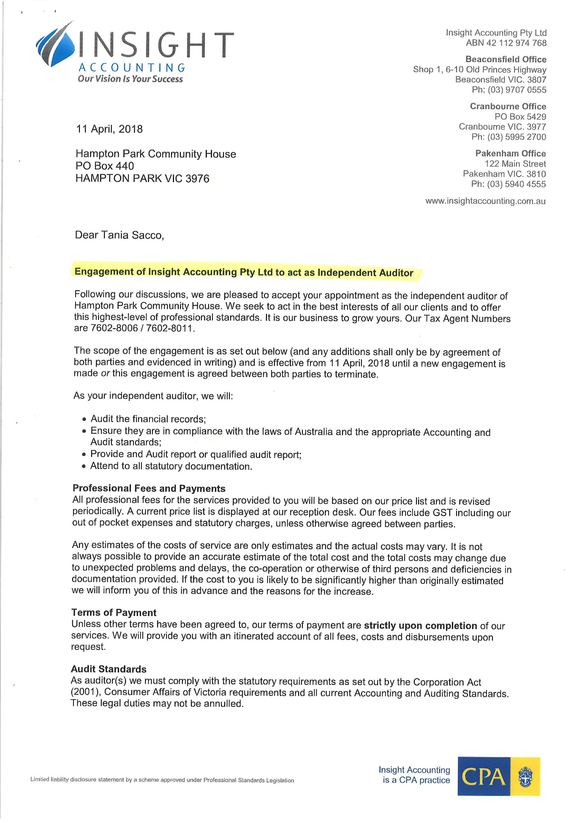
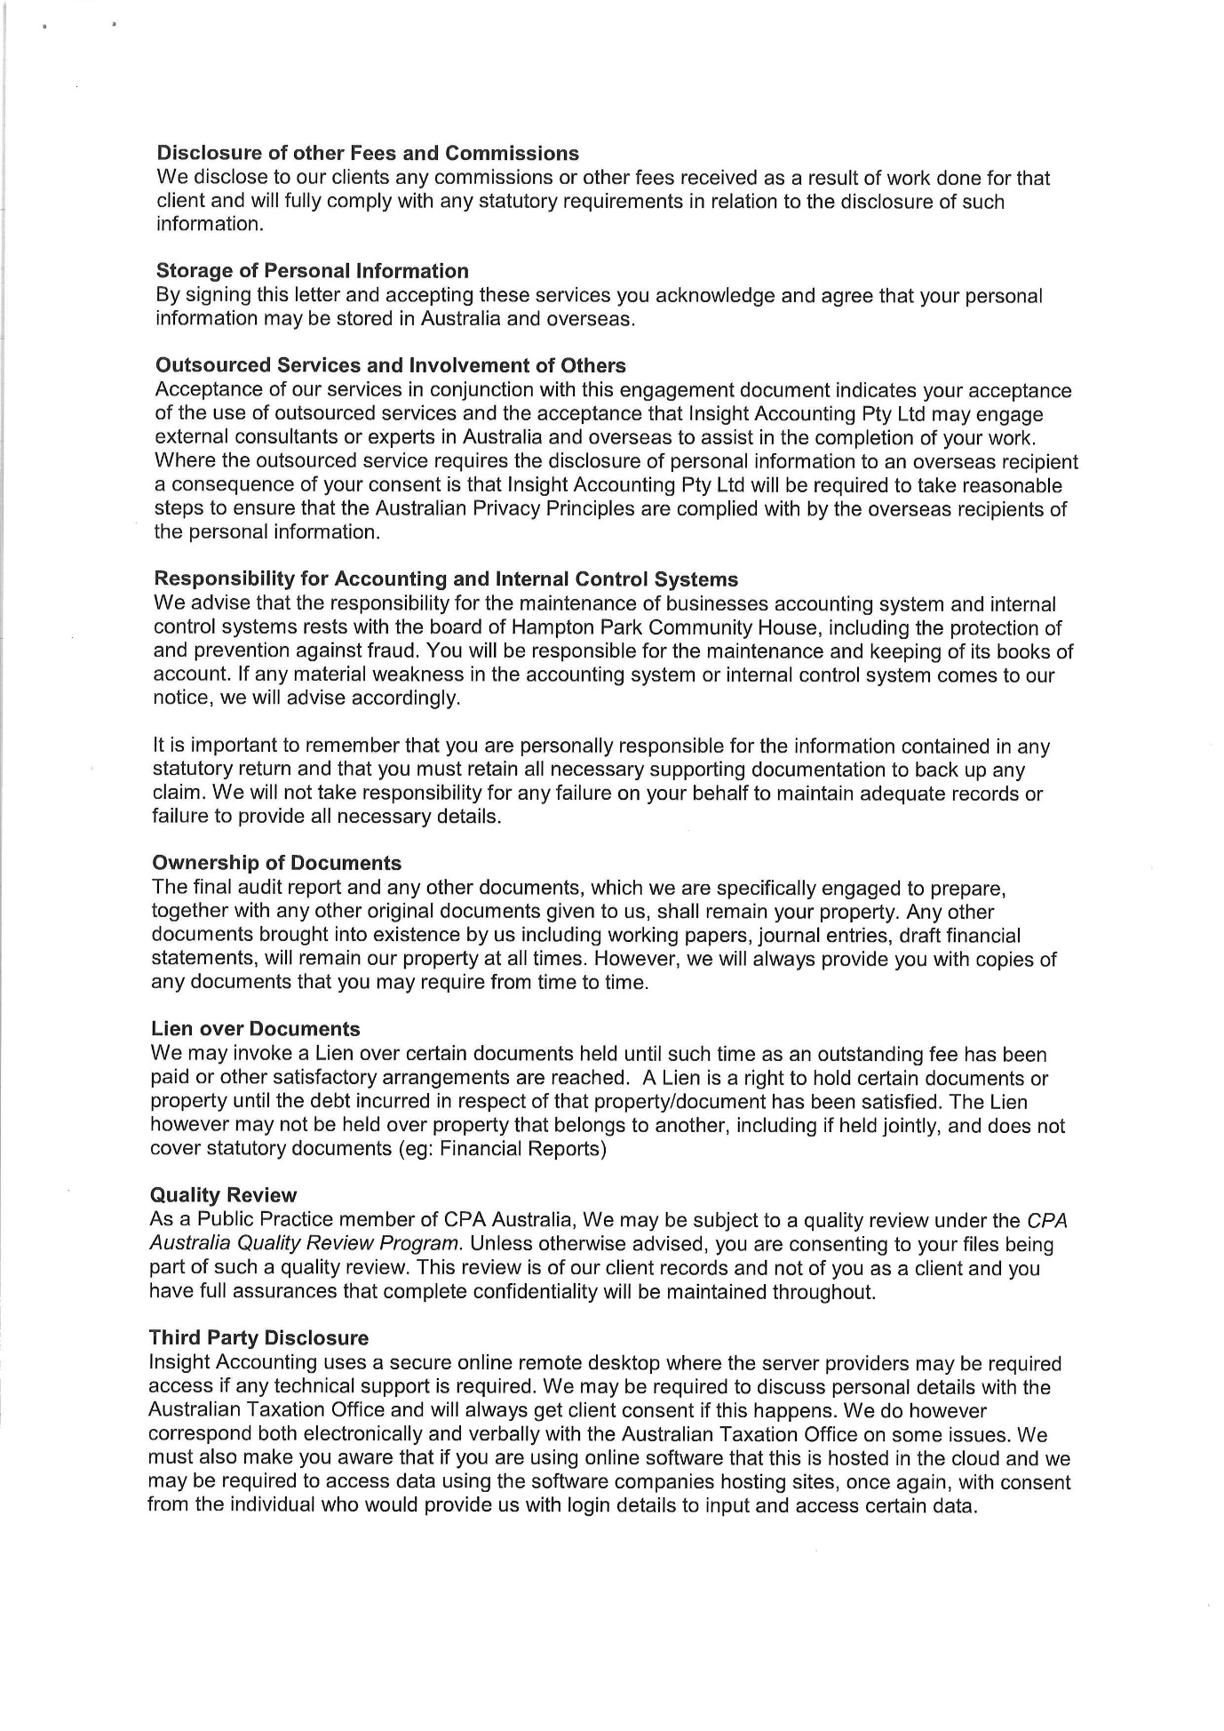
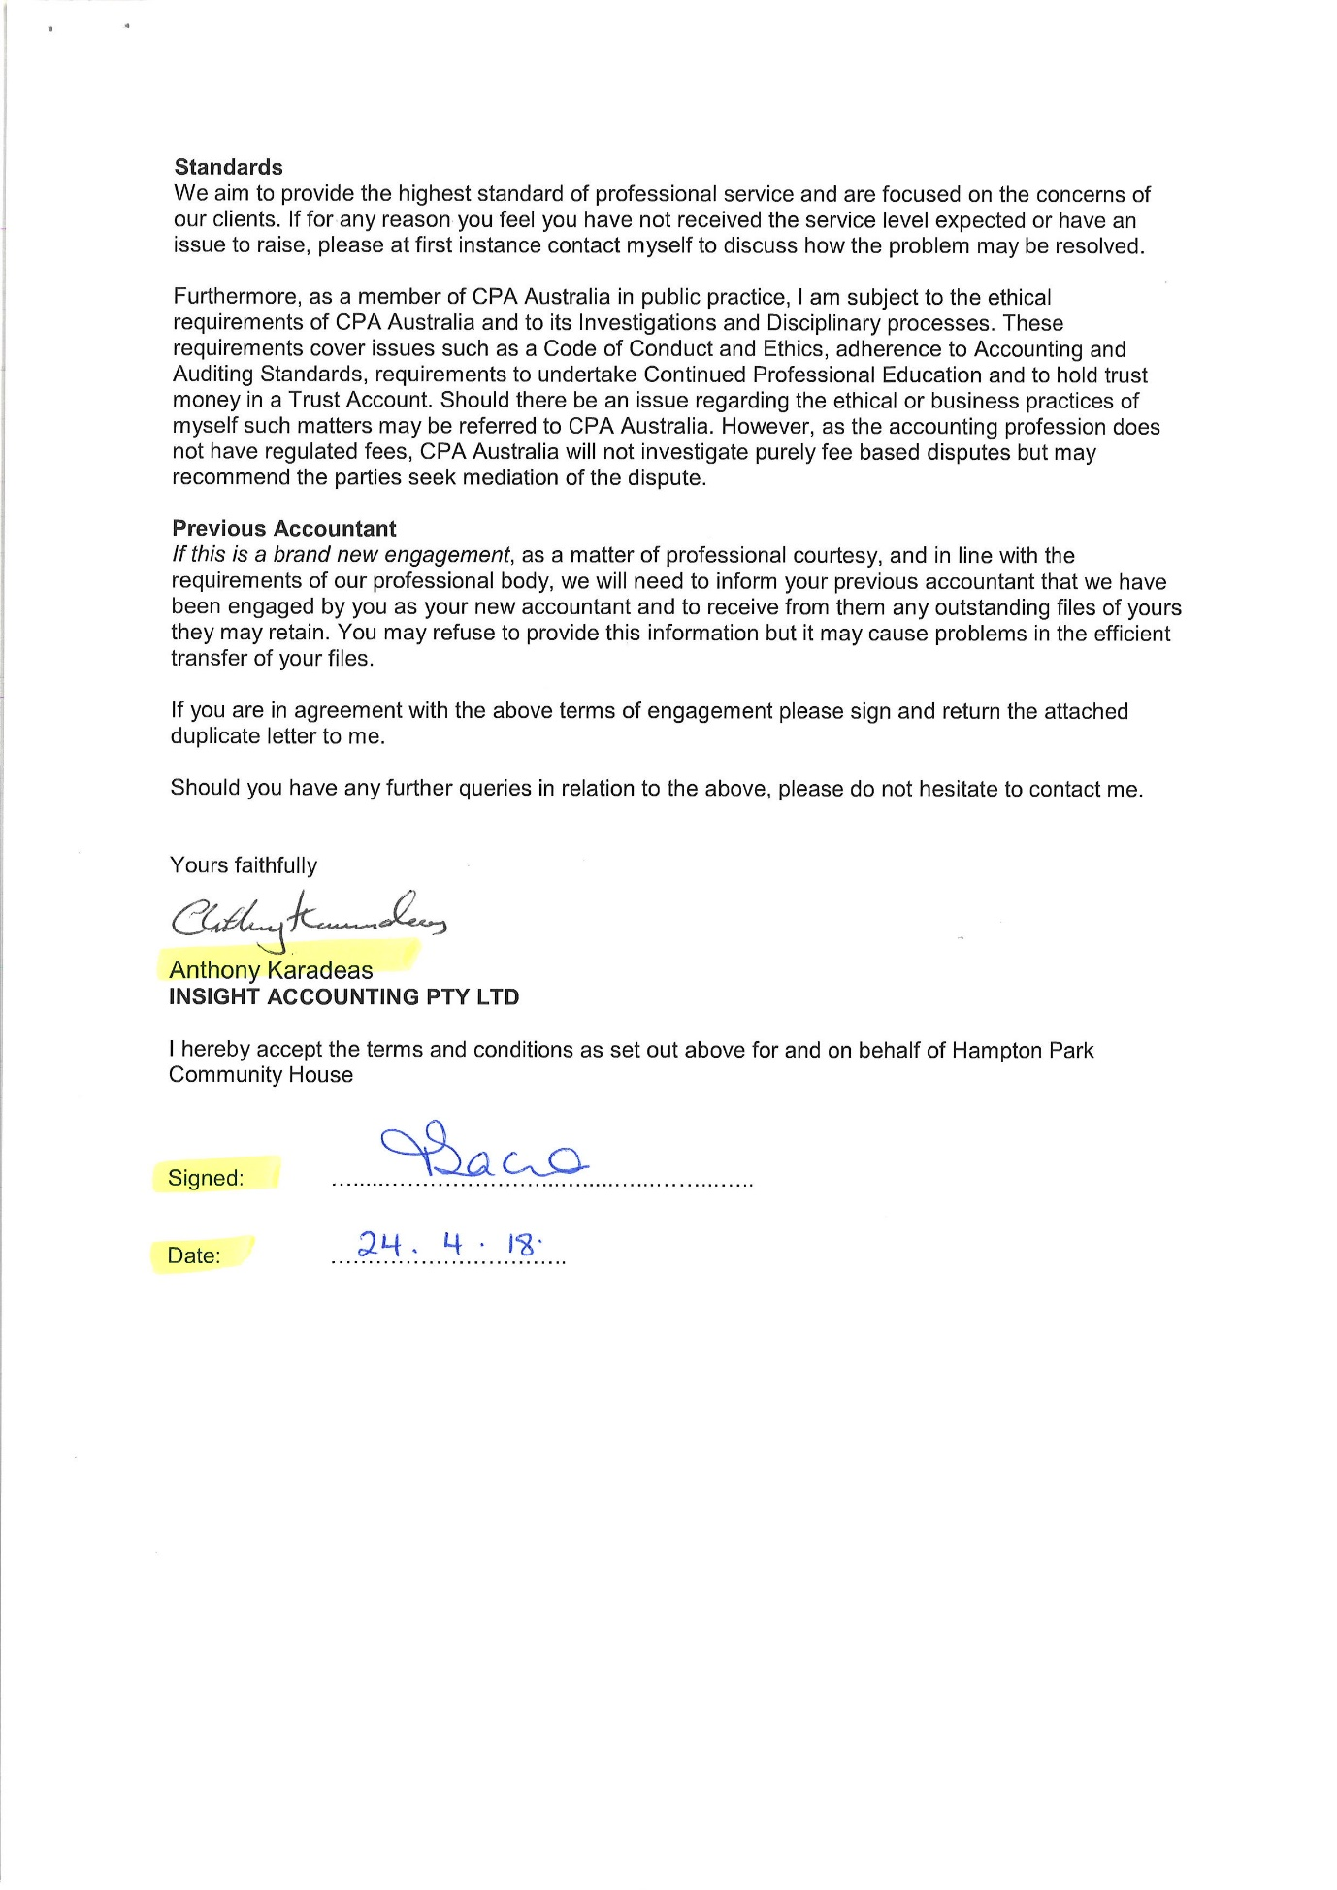
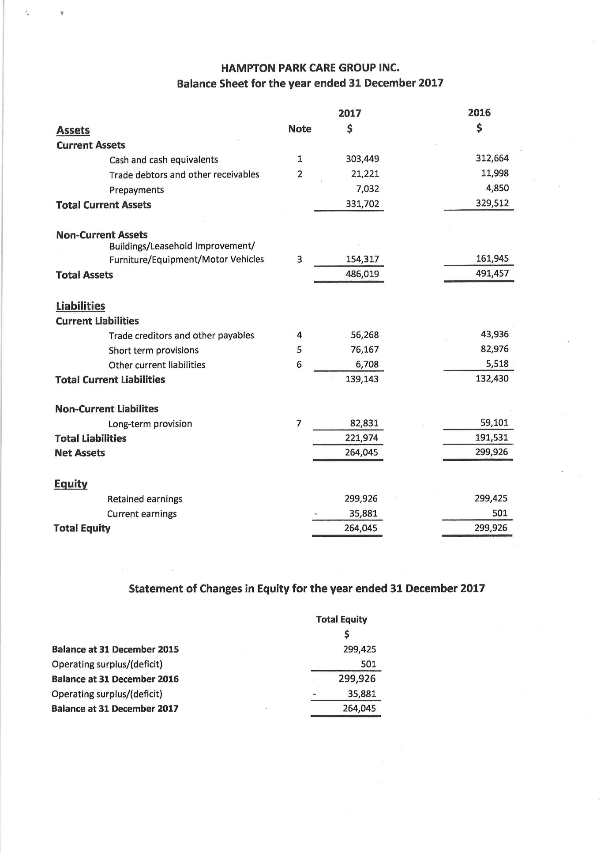
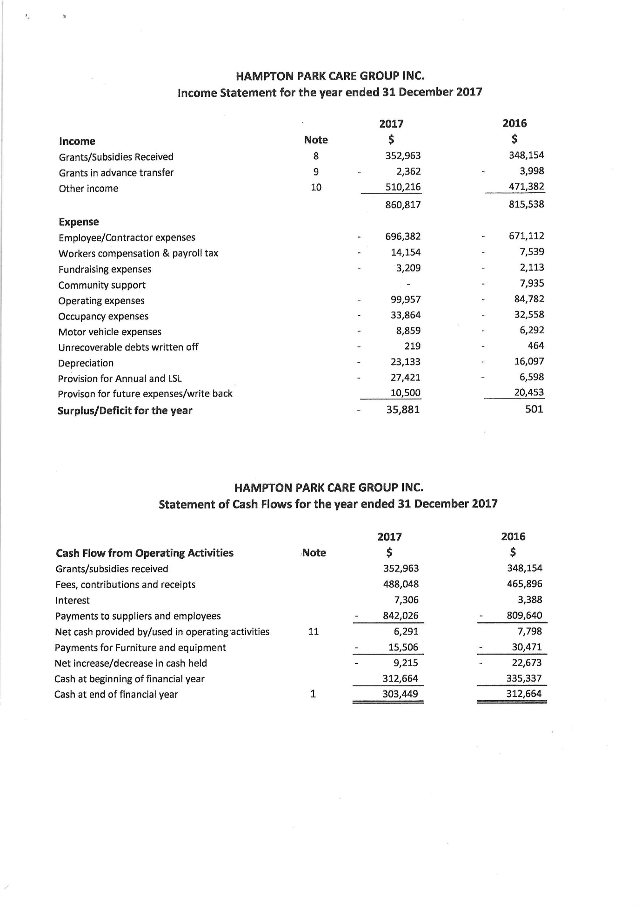
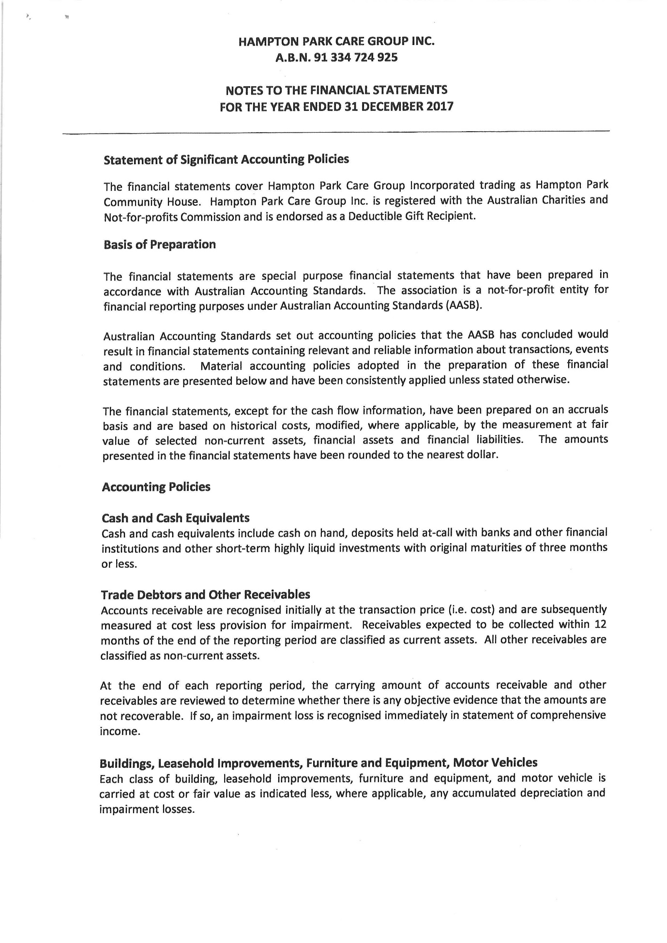
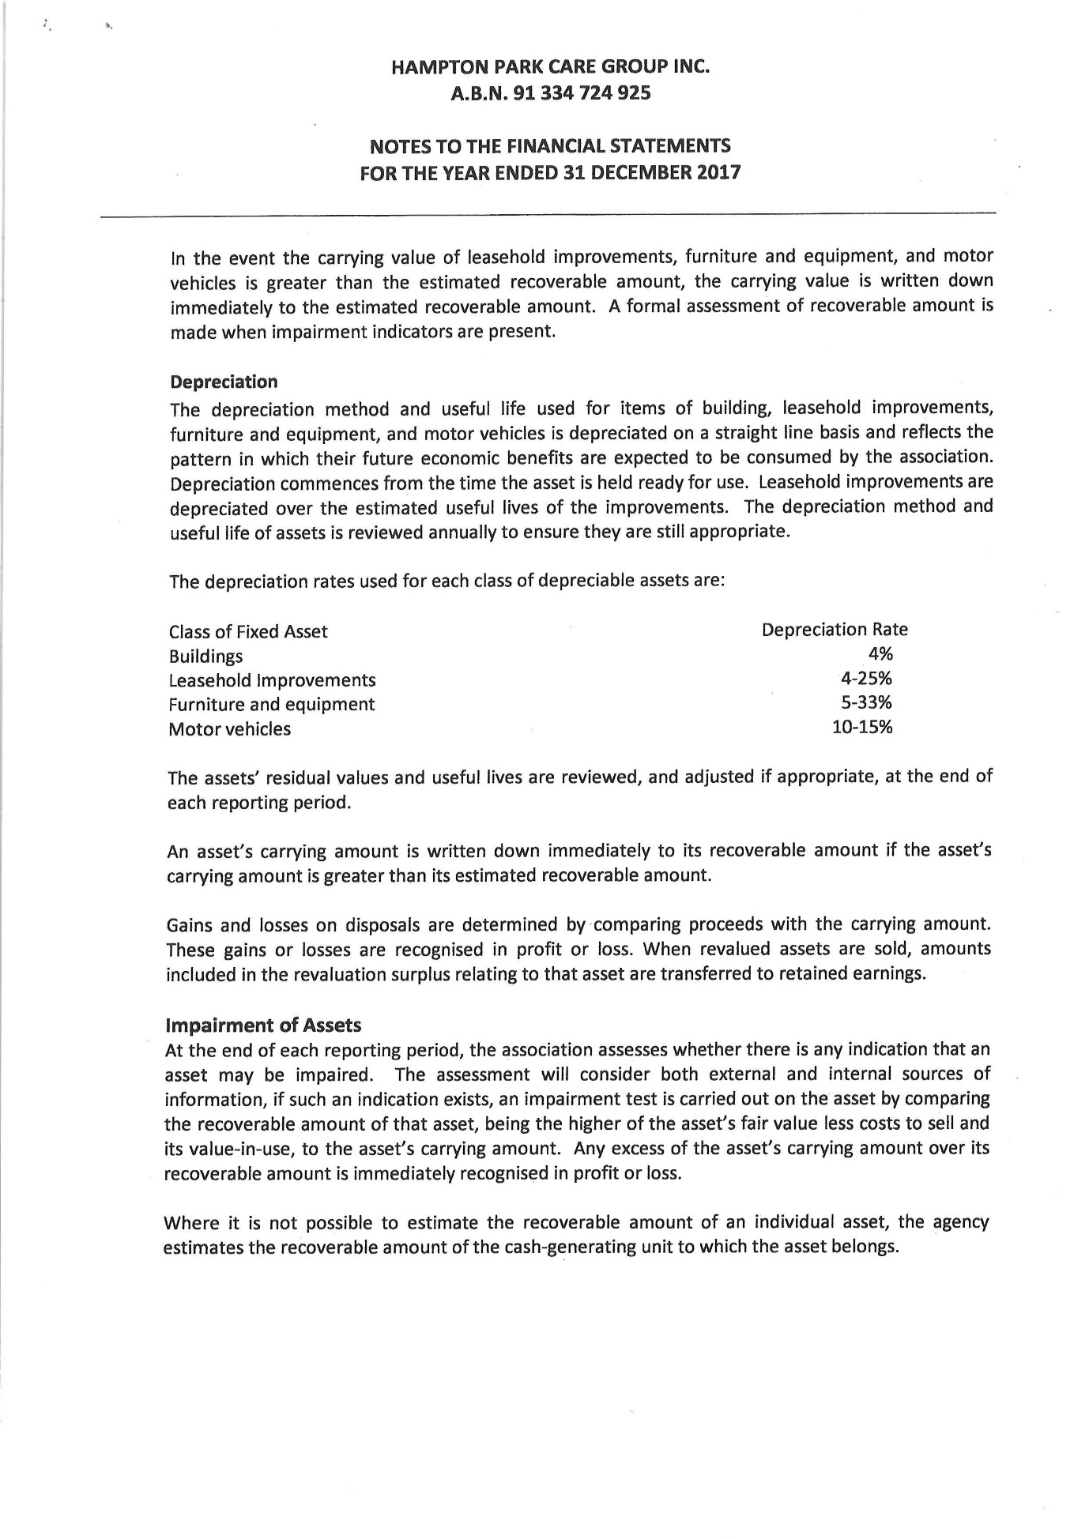
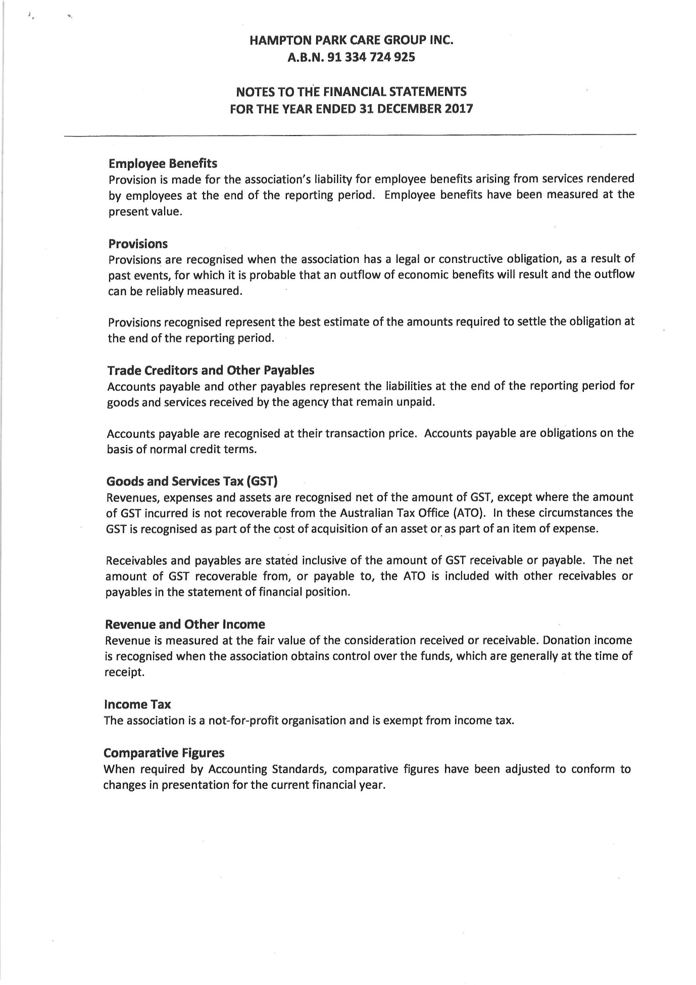
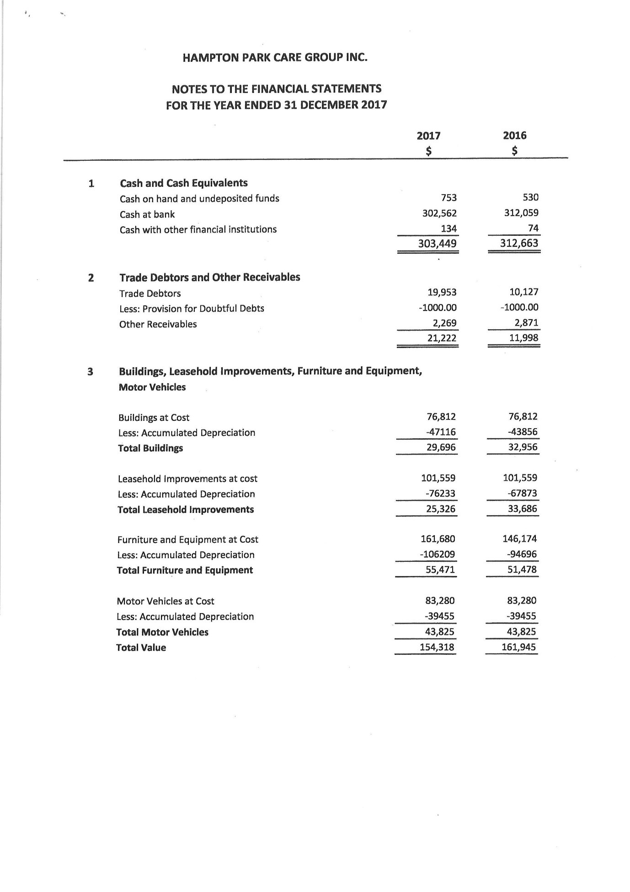
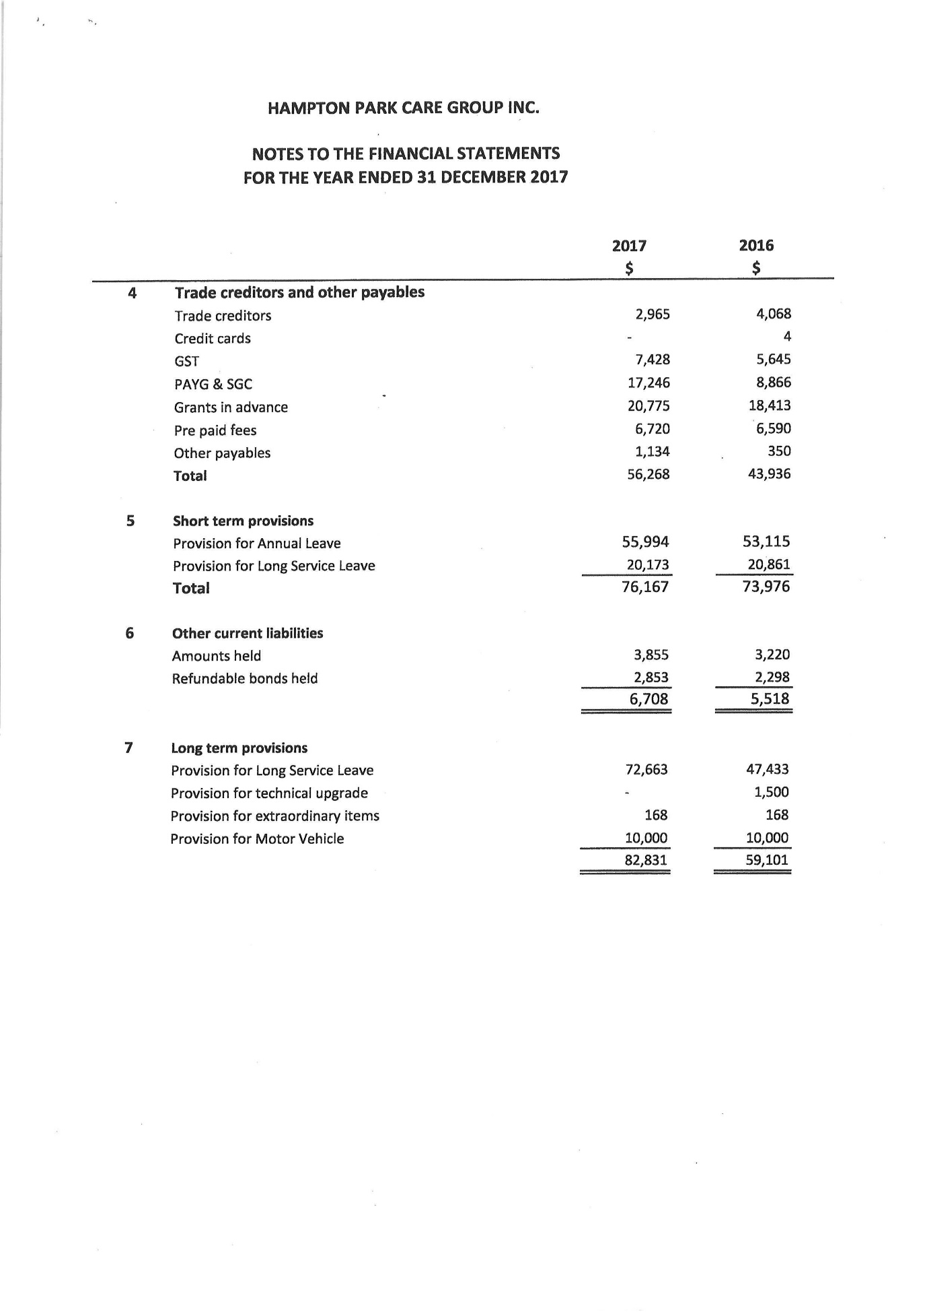
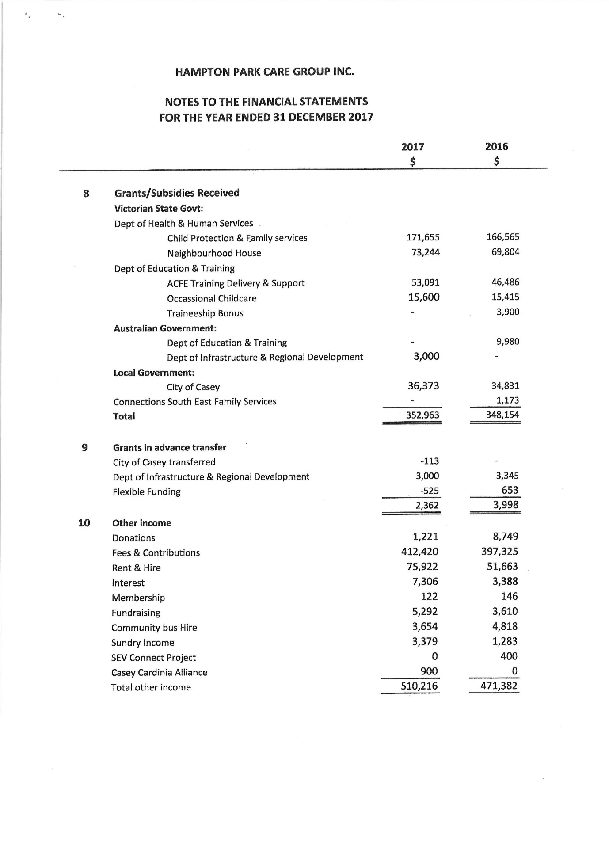

EARLY CHILDHOOD
I am pleased to present the report for 2017.
We had a very busy year in our Occasional care and Pre-Kinder areas. Our Occasional Care caters for children from “Culturally and Linguistically Diverse” (CALD) families, Take - a – break parents, Children in need of socialisation and also for a large number of children form the “Adult Migrant English Program” (AMEP).
Our occasional care figures, had an increase compare to other years, this was due to AMEP utilizing our service 3 days a week (Wednesday, Thursday and Friday). To providing a safe, caring environment and cover ratio we employed Amatul Aziz who holds a Diploma in Children’s Services, and has worked with children for some time, and has being enjoying working with us. We also employed Tania Pateman who has a Certificate III in Children’s Services and has being working in OSH for many years, we are very happy to have her in our team.
Our Pre-Kinder area was very successful. We were able to provide 4 morning sessions and one afternoon sessions of Pre-Kinder throughout the year.
The Victorian Early Years Framework guidelines pinpoint the curriculum which is delivered for the children. Our Educators plan play-based educational programs to support the children’s learning. The programs are planned to meet the individual needs and interests of each child.
Through the year we were able to provide children with a broad range of learning experiences, such as the very popular playdough, box construction, bathing babies, home corner, book area, puzzles, Lego, blocks, dressing up, hairdressing; mechanics, variety of imaginative play; music and movements, we also provided lots of art experiences such as, painting, pasting, using clay, sand and natural materials and let us not forget the very popular out-door play, where they enjoy the sand pit, cubby house, climbing, water play, riding bikes, cars and ball games.
Our Pre-Kinder groups really enjoyed many different and exciting special activities this year which included. Celebrating “Harmony day”, “Mother’s Day”, Father’s Day”,
The highly anticipated teddy bear picnic where children brought their teddies from home and enjoyed helping ice teddy bear biscuits. Some Pre kinder groups also enjoyed some simple cooking activities.
We cannot forget the wonderful visit from Ray the official representative of CFA who came to talk about Fire Safety and the celebration of end of the year and Christmas party” the favorite of many.
I would like to acknowledge the wonderful job our kinder Educators do as it is a big commitment to present each family with their child’s portfolio at the end of the year.
We had Foons Photographic came in to photograph our kinder children; this provides families with great future memories of their children’s early childhood year.
Through the year, we had 2 students, Michelle P. from Merinda Park Learning and Community centre and Willow from Chisholm Institute doing their placement with us (Children services certificate III).
During the month of November and December Jan O’Callaghan and I in collaboration with Kate Noble undertook and completed performance reviews with all staff from OSH and Childcare. The reviews were very helpful to highlight and identify what is working and what needs to be improved.
Many thanks to the childhood educators for providing quality care for the children. Sandra, Wendy, Zeinab, Amatul, Tania and Patricia are dedicated educators, being always ready to help and support each other and myself. Big thanks to Ray, who was a fantastic Santa for us this year.
A big thanks to Jessica and Laura, our volunteer staff for always, willing to help us in whatever is needed to be done.
I would like to take the opportunity to thank Jan O’Callaghan for her support and encouragement as she guides me towards her role in OSH. I am very grateful to have such a special person guiding me through this transition.
I would like to thank all of the other staff that has supported our area and me as the Early Childhood Manager this year. Tania Sacco as House Manager, for her time spent guiding and helping me with daily issues. Kate Noble who has being a great help and mentor for me
Big thanks to Diane Spencer for her wonder full job she does in our area, Jan Davies and Janine Gablek as Book Keepers, Edith Schaaf and Jen Schutze and Megan Stewart as family support, Jan O’Callaghan and all the O.S.H. Educators and let’s not forget Sandra Hoy on Reception.
Thanks to The Board of Governance 2017 for the great continual support to The Early Childhood program at Hampton Park Community Centre.
I would like to wish the new Board of Governance all the very best for the year 2018.

Early Childhood Manager
Queenie Tirado

OUT OF SCHOOL HOURS
It is my pleasure to present to you my final report for the out of school hours care program for 2017.

Once again our numbers fluctuated all through the year for both before and after school care. Whilst our vacation care program remained steady with good numbers. The children attending after school care rediscovered their love for reading and so every Tuesday the Educators would walk anywhere up to 18 children to the library where they would spend 30 minutes browsing and choosing the books they would get out for the week. It really was nice to see the children have an interest with something that wasn’t plugged in! The children have also enjoyed getting back to nature and have learnt all about recycling and composting and love to help in our little garden by planting, weeding and watering. They also have an interest in bugs and watching and playing with our two resident lizards, Lightening & Turbo. On the artistic side of things, we were lucky to have the services of Mary Murphy who came in and did art with a group of children on a weekly basis. Thank you Mary.

Our offices and work areas were freshened up with a new paint colour and towards the end of the year new cupboards were installed in the childcare area. It has made such a difference to the look of the area and was a great way of decluttering. Thank you to the City of Casey.

Most of my time this year seemed to be spent on accessing Inclusion support for two of our special needs children. Let me be blunt, it was a nightmare. Something that used to take a matter of a few weeks dragged on from April through to December, all thanks to modern technology. What used to be done by hand with the good old fashioned pen and paper, has now been replaced with a portal. Most of the time I couldn’t access this marvel of technology. It was extremely frustrating, but thankfully it only has to be done once a year and hopefully all the kinks will be out of the system the next time we need to use it.

As I said before our vacation care program is still popular and having a longer time with the children means, we can get many good things happening. Some of the activities the children participated in were:

- Craft such as: sun catchers, monster rocks, kite making & flying, wind up snowmen,
greeting cards, paper weight, paper fox, and bookmarks.
- Incursions/excursions: ten pin bowling, puppet theatre, hip hop dance group, Cranbourne botanical gardens, Taskworks, Kryal castle and Splashtastic water games.
- In addition, the children took part in lots of cooking, disco day, PJ’s days and movies, crazy hair and nails, face painting, henna hand painting, wheels day, messy day, Games day, chocolate making, science day, masquerade ball, circus day, nature day, talent quest and Community day. We certainly kept the children busy.

The children in our programs love to come to us and this is possible because of the terrific staff that we have. Therefore, I would like to thank the following people.
Sandra Palmer, Queenie Tirado, Patricia Tirado, Zeinab Shaheen, Kathleen Reale, Crystal Foxal, Shannon Marchant, Tania Pateman, Alice Savoury and Jane Cameron and Claudia Alvesio for doing the afternoon tea every day for the children.

A special thank you to my administrative assistant Janine Gablek for getting the invoicing out on time, helping with the vacation care program and being a good sounding board.
Lastly thanks to all the office staff, house manager Tania and all the board members for your support throughout the year.

As I stated at the beginning of my report this will be my last one as I will be retiring this coming September. I have been a member of staff here for 30 years and the Director of the Out of School Hours care program for 11 of those years. My how things have changed in that time. I have been privileged to have worked alongside some amazing women and a couple of gentlemen and have had in my care some terrific children. In one way or another, they have all made my life richer.

Thank you
Jan O’Callaghan

PLAYGROUP
2017 has been a great year for playgroup, we have had a large number of families attending throughout the year. This year we have seen a continued rise in the number of grandparents and family day carers accessing our playgroup. Playgroup gives families and carers a regular meeting place outside of their homes that is safe, secure and welcoming. This gives everyone a chance to meet on a regular basis in a familiar place to:
- Exchange thoughts and ideas on parenting
- Establish new friendship circles
- Maternal Child Health is attending each playgroup every term answering questions and concerns and has made referrals for families to attend other professional services
- For the children to develop social/emotional skills
- Learn about other cultures
- Accept each other no matter what our abilities are
- Pete’s Clothing has attended playgroup throughout the year with parents snapping up lots of bargains
- Through playgroup we hope to encourage families to attend regularly and to start thinking seriously about attending occasional care and 3-year-old kinder, which is a good stepping stone towards 4-year-old kinder and their child’s future
- We have incorporated a variety of celebrations into our program throughout the year including Harmony Day, Easter, National Simultaneous Story Time, Dental Health Week, Mother’s Day and Father’s Day, just to name a few
- Music time continues to be of great interest to children and their careers, particularly when we add in scarves, shakers and the musical instrument box. Parents have been actively encouraged to bring in a song from home to share with the group.
- Lots of interest in the vegetable garden in particular the strawberries and tomatoes
- The vegie garden creates a lot of chatter among families, comparing what they are growing, offering each other advise and tips even sharing plants with each other
- The vegetable wall has created a lot of interest with some taking photos for research for their own backyard.
- The small compost bin which we keep on the snack table for all to use is working well, the children tend to remind their parents to use the compost bin and not the rubbish bin, at the end of the session one of the older children usually empties this into the big compost bin down the back in the garden
- The addition of the small bridge in the garden has created a lot of interest with the children. The bridge has been well used by all children and unfortunately it is in need of a repair or a replacement of something bigger and stronger.
The City of Casey once again has provided a great end of year party at Myuna Farm which is available to all playgroup members and their families throughout the City of Casey. All who attended had an enjoyable time.
The lovely Ladies in the spinning class have welcomed in the parents and children to have a look at their creations. The Ladies have offered to help the parents learn the craft of knitting and crochet. The Spinning Ladies have also been donating items to the children to use for craft. Thank you for allowing us to join in on your fun.
We decided to have two separate parties for end of year break up as this seems to suit everyone. Santa arrived bearing gifts and lolly bags for all, much to the delight of the children. I would like to express my thanks to our wonderful Santa Fireman Ray who did a wonderful job. The children and parents were happy with the gifts that they received as well as the compulsory lolly bags and Christmas stockings that Sandra Marks crochets for us from wool that has been donated over the year, I then fill them with chocolate frogs and candy canes.
This year we went to Scholastics Book sale in Hallam to purchase the books for the Christmas Party. With finding some great deals at the sale I then went to their ware house in Heidelberg West for some more bargains, which we found!
This year for fundraising we have continued on with selling the chocolate frogs throughout the year. Sandra Marks has been taking boxes home and selling them quicker than we can get more boxes in to replace what has been sold. Thank you, Sandra Marks, for being our number one seller of chocolate frogs!
Once again, we had a jumping castle for our Christmas party, this was well used by the children and some of the parents, as the jumping castle arrived early and left late (6:15 pm) the OSH children were able to make good use of the jumping castle as well.
I would like to say thank you to all of the volunteers who have willingly given up their time so regularly in particular Sandra Marks, Jessica Riddiford, and Laura Palmer without the help of these lovely people Playgroup would struggle to run. I would also like to say thank you to all staff and committee members for their help and support throughout the year. All at Playgroup are looking forward to a successful and fun filled year next year.

Playgroup Coordinator
Sandra Palmer

FAMILY SUPPORT
I am pleased to present this year’s Family support report.
It has been a very exciting year in the Family Support Office. Family Support had their HDAA Audit 2017 and met the requirements of DHHS Standards and National Standards for Disability.
Family Support ran an OP Shop helped by Sandra Marks (Volunteer) throughout the Year to support some of our client with Clothing and Christmas presents at the end of the year. Jen Schutze is working extremely well in Family Support. She is a great asset and works extremely well to support our families.
Family support service has had a very busy year, supporting many clients throughout the year, this includes families, couples and children. Family Support receives referrals from Child First / DHHS, as they are the provider of our funding.
Family Support has case managed 78 clients over the year, many of the issues covered and supported were Parenting support and Education, School refusal, Child Behaviour and Bullying, Isolation and Depression, Family violence, Drug and Alcohol, Grieve and Loss, Relationship counselling and Migrant concerns.

Feeling is Thinking Group
The Children’s Feeling is Thinking Group (FisT) is performing well and is reaching capacity every term. Edith (HPCH) Family Support and Kristy or Ethan and other Case managers from Windermere are responsible in keeping the group running successively. We have had 29-34 children go through the HPCH Feeling is Thinking Group in the past year and have seen many outstanding accomplishments for the children who joined the group.
Feedback for Feeling is Thinking demonstrates that the program makes a positive difference in the lives of the participants and their families. Post-group parent scores emphasised that their children had improved competence and confidence with managing their strong emotions and ability to cope with tough situations they may face.
This group will be continuing during the course of next year and numerous years to follow. To see the changes in the children’s life is indescribable, I am delighted to be part of their lives for a short period of time.
Participants’ parents often noticed changes in the way their children who had completed the program are behaving at home. This shows that the program is not only beneficial for the participants in the short-term; but that the participants had actively taken the information learned on board and put it into practice in their lives.

I would like to take this opportunity to thank the Board of Governance for their support during the year also to say thank you to the manager of the HPCH Tania Sacco for her support throughout the year.
I would like to say thank you to Michael Scargill for all his volunteer hours during the year with IT and the Feeling is Thinking Group work. Thank you to Sandra Marks for her support with the OP Shop. Thank you to Diane Spencer, Sandra Hoy and all other members of the HPCH for their support.
A Thank you to all the Agencies who supported Family Support during the Year with their Donations for the Families.
A big thank you to DHHS for their funding and commitment of this Area and to Moritz Muckenberger for his continued support.

Family Support Coordinator
Edith Schaaf

PROGRAM COORDINATOR

House Program
- Room Hires for Tai Chi, Spinners & Weavers, Senior’s Craft, African Drumming, Men’s Group and other long term patrons will continue as per previous years. Our association with Chisholm and their AMEP involvement continues in 2018 so various spaces are being rented three days per week. This helps to offset the decline in classes we would like to run for the community if we had stronger numbers. We still receive expressions of interest and ideas for classes but student numbers are usually only 1 or 2 despite advertising and promotion.
- Flexible Computer Training & Evening Flexible Computer Training – Course feedback from the students indicates a desire to continue these classes next year. Contact with these students will be made during January to confirm attendance.
- Intermediate English – there were too few students to continue with the ESL class in this format so it will be replaced by an Intermediate English class funded via a grant to the Women’s Friendship Café. It is still the same conceptually with; conversational English promoted by craft as a focus which keeps it informal and friendly for students. We hope it will encourage the students to want to continue the class after the funding has ended to become a source of revenue.
- Employment Skills – Wednesday and Thursday - The Bridge - Springvale, off campus continues to support community members who have disabilities with an Employment Skills program. I have met with Yvette and Glenda to introduce herself and become familiar with the environment, see the program being run and contribute to the Moderation process for Term 4. The quality of learning and enthusiasm of Facilitator, Program author and other staff is impressive.

To show the current Class Numbers and the Hours used, please see the corresponding reports at the conclusion of this document:
◦ Class Hours by Category and
◦ Class/Activity Numbers
- The annual Needs Analysis document was completed before the House closed in December. The report reflects a continuation of previous findings, in that the community’s current demographic is still wanting to engage in activities in the House but are reluctant to pay for classes when they are able to source similar programs for free e.g. Learning English. The low level of interest and willingness to pay, means that classes cannot be run as tutor costs are quite high.
- OSH Program - After meeting with the Community Engagement Coordinator, Tori Norris, and Jan O’Callaghan, OSH will participate in a pilot program (after school) named ‘Mindful Play Children’s Program’. The structure and content were of a high standard, is endorsed by Council and free of charge. The program will commence on 1st March for 5 weeks.

Marketing and Social Media

Social Media:
- Coupled with referrals and recommendations, Facebook marketing is still the main way of advertising our Children Services, House/Room and Bus rentals etc. We continue to promote the services and talents of our staff but protect the children by only posting photos which do not identify them.
- To better promote some programs, classes and events, certain Facebook posts are given a ‘boost’ which costs a small nominal fee but reaches a wider audience.
- The House Brochure is updated regularly and displayed prominently at Reception both as information and for advertising purposes as we do have drop in visitors, contractors, etc.
- The website is also updated to ensure information is current and relevant.
- Survey Monkey has been explored but can only be effective if we had a database outside of other Neighbourhood Houses and our current clients as it is an ‘opt in’/permission based platform. May explore this further in 2018 and also Instagram to understand its potential for us.
Thank you to Jen Schutze, for the terrific job she has done in the role. Her support whilst I was/am learning has been invaluable and much appreciated. I am comfortable with the HR responsibilities and have been able to take over most of the programing/marketing duties but am still supported by Jen and Tania to ensure all requirements are met whilst I get across all aspects of the position. This is both a relief and greatly appreciated because of their knowledge and expertise in the area.

Human Resources
New Staff Member: Amatul Aziz – Childcare Assistant (Casual)
Megan Stewart – Family Services - Support
Kate Noble – HR/Marketing/Programing Coordinator
Staff Resignations: Nil

All staff Performance Reviews bar one * with KPIs have been completed. Tania’s plan was for the HR Manager to sit in on most reviews to ensure process consistency whilst supporting the Coordinator and Director as they become comfortable with this responsibility. I thought Jan and Queenie handled all reviews professionally and where possible with humour which helped to keep things light. (This is important because some staff had not undergone a review before and it can seem daunting.) It is my understanding that issues that were brought to their attention were followed up. The staff in turn, were equally professional. We appreciated their honesty and goodwill, as we can’t address matters if we aren’t aware of them.

As the staff have become more familiar with having a permanent H.R. presence on site, some other issues have been raised and addressed by either myself or redirected to the relevant Manager. My role is then to support the Manager if requested or inject myself into proceedings where compliance or information is needed. The staff have been receptive and understanding where this has been the case. Tania is kept across all issues and involved when necessary.

Finally, I am really enjoying my role/s here at Hampton Park Community House. The staff are welcoming, great to work with and extremely supportive. I feel privileged to have been chosen to work here.

Assistant Manager

Kate Noble

Words from the MANAGER
Good evening everyone and welcome.
2017 saw me enter my 4th year as Manager of the Hampton Park Community House and we get busier and busier every year.
As always, I have to say a big thank-you to the whole team at the House. Every one of you contributes in many and varied ways to the success of the House. While we had a tough year on the financial front, we were beyond successful in the growth of our team as a whole. We strive to provide best practice in the way we relate with each other and with the community that we serve. A lovely example of this way during the Art Show when the Judge came up and congratulated me on the brilliant community house. I immediately said that I could not take the credit for all the hard work put in by all and in particular Heather Sheppard. At this point, he corrected me and said he meant the vibe of the House. He said you could feel the happy and friendly vibe as soon as you walk in. We get this sort of feedback all the time and it is a testament to all that live the mission vision and value statements of the Hampton Park Community House.
We had a lot of exciting change at the House in 2017. We had a new Food wall/vertical garden installed and new washing machine/dryer, thanks to grants provided by City of Casey. I want to take this opportunity to thank the Community Strengthening team at Casey that we deal with on a regular basis. We appreciate the time and energy you provide to help the HPCH support our community. Also through COC Minor Capital Works programs, we were able to revitalize the childcare rooms with brand new cupboards and provide much needed storage with new palleting in the storage garages.
Another new project was just outside our front door. In conjunction with a safety grant and City of Casey, the front area outside the Community House was revitalized. We have brand spanking new landscaped area that includes a half basketball court.
We had an exciting Art Show that was a huge success and brought many new and old faces into the House. Heather Sheppard is a much-treasured Life Member of the HPCH and the driving force behind the Art Show; we are very much looking forward to the Art Show in 2018.
We expanded our workforce during the year to bring a much-needed focus to the HR side of the House. We now have a dedicated resource to help support our staff and volunteers. Our workforce has grown considerably over the last few years to meet the ever-growing needs of our community. We have a greater demand for English classes and associated childcare to support that, so we are very pleased to have a wonderful partnership with Chisholm to support our community with this.
We constantly grow current partnerships and develop new ones to be able to support the needs of the Hampton Park Community. One that I particularly want to mention is the Hampton Park Progress Association in conjunction with the Arthur Wren Hall. We work on many joint projects and the HPPA are always ready to assist when we put out the call.
It would be remiss of me if I did not go on to thank all our funding bodies at this point. Without them, we would not have the backbone of financial support to run all the programs at the House. So thank-you to the:
- Department of Health and Human Services (DHHS)
- Adult Community and Further Education (ACFE)
- City of Casey (COC)
- Neighbourhood House Victoria (NHV)

We are also extremely lucky to have a Board with a clear understanding of Governance. One that supports me as Manager and gives 110% to commitment to the HPCH and the HP community at large. Most people do not see all that you do, but I do, and I thank-you.
Just a little reminder that next year we celebrate 30 years in this building so stay tuned for updates on the celebrations.
Lastly I would like to thank the community that is HP. You support and encourage the best of your community house and I am sure that with all of us working together, we will go onto bigger, better and amazing things.

Manager
Tania Sacco

APPENDIX

Board of Governance 2017

Chairman
John O’Callaghan

Vice Chairman
Carlos Santin

Treasurer
Ian Ash

Secretary
Christie Fox

General
Michael Scargill
Sharon Corby
Christine Simmons
Sahar Batool

Community House Staff 2017

House Manager
Tania Sacco

Office Manager
Diane Spencer

Assistant Manager/HR
Kate Noble

Administration
Sandra Hoy
Jan Davies
Janine Gablek
Megan Stewart

Out of school Hours
Jan O’Callaghan
Kathleen Reale
Claudia Alevizos
Jane Cameron
Tania Pateman
Crystal Foxall
Zeinab Shaheen

Child Care
Queenie Tirado
Sandra Palmer
Patricia Tirado
Wendy Slavovic

Family Support
Edith Schaaf
Jen Schutze

Programs & Volunteers
John Dowswell
Sandra Marks
Elaine Youens
Jessica Riddiford
Laura Palmer

Friends of the House
Sue Stephens
Elaine Smith
Heather Shepherd
Melinda Perry
Hampton Park Men’s Group
Warren Calder
Lynda Smith
Vanassa Gerdes
Dandenong Neighbourhood House
Hampton Park Library
Hampton Park Youth Centre
Hampton Park Networking Group
Hampton Park Progress Association
Community House Network –CHN
Casey Cluster

Acknowledgments

For the continued assistance and contributions, Hampton Park Care Group Inc. would like to thank:

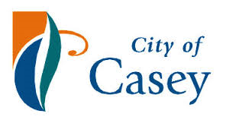

The Community House Network and all of our wonderful volunteers
Thank you.

