

## Hampton Park Care Group Inc.

## 2014 Annual Report

Presented at the

Annual General Meeting

20th April 2015, 7.30pm

Hampton Park Community House

16-20 Stuart Ave,

Hampton Park, 3976

Ph: 9799 0708

Website: [www.hamptonparkch.com.au](http://www.hamptonparkch.com.au)

CONTENTS

Agenda

Previous Minutes

Chairman’s Report

Treasurer Report & Financial Statements

Staff Reports

Manager’s Report

APPENDIX

Board of Governance 2014

Staff 2014

Acknowledgments

AGENDA

*Hampton Park Care Group Inc.  
Annual General Meeting 2014*

1. Welcome

* 1.1 Attendees
* 1.2 Apologies

1. Previous Minutes
2. Words from the Chairperson, John O’Callaghan
3. Treasure’s report & financial statements for the year ending 31st Dec 2014
4. Early Childhood Report
5. Out of School Hours Report
6. Playgroup Report
7. Family Support Report
8. Program Co-ordinator Report
9. Manager’s Report
10. Election of Board of Governance
11. Gift presentations
12. Guest Presentation
13. Close

Light supper to conclude the evening.

MINUTES

*Hampton Park Care Group Inc.  
Annual General Meeting 2013*

**Venue**: Hampton Park Community House

**Date**: Monday 19th May 2014

**Time:** 7.30pm

**1: Welcome:** Meeting opened by John O’Callaghan 7.40pm

**2. Attendees:** Christie Stoneham, Peter Hanson, Sandra Hoy, Alison Kramer, John O’Callaghan, Julie Sullivan, Sandra Palmer, Ann Green, Edith Schaff, Michael Scargill, Jan O’Callaghan, David Maxwell, Queenie Tirado, Sandra Marks, Diane Spencer, Lynda Smith, Jan Davies.

**3. Apologies:** Shirley Borlase, Sue Murphy, Mary Murphy, Kathryn Ballis, Debra McCowatt, Tania Sacco, Sue Stephens, Diana Spano, Lynda Wilkins, Elaine Youens.

**4. Acceptance of Previous Minutes:** As read.

Spelling amendment in treasury report from Inside Accounting to Insight Accounting.

Moved: Peter Hanson

Seconded: Michael Scargill

**5. Chairman’s Report:** As written and read by John O’Callaghan.

**6. Treasury Report:** As written and read by Ann Green.

Ann Green would like to recommend we nominate Insight Accounting Pty Ltd for Hampton Park Care Group’s ongoing accounting needs.

Moved: Ann Green Seconded: Christie Stoneham

**7. Early Childhood:** As written by Queenie Tirado.

**8. Out of School Hours:** As written by Jan O’Callaghan.

Thank you to all staff and board for their continued support.

**9. Playgroup:** As written by Sandra Palmer

**10. Family Support:** As written by Edith Schaaf.

Thanks to Lynda Smith, the Board of Governance and the workers that have helped to support me in my role in family support.

**11. Program Co-ordinator:** As written by Tania Sacco.

**12. Manager’s Report:** As written and read by Lynda Smith.

Moved: Michael Scargill

Seconded: Peter Hanson

**13. Election of New Committee 2013**

“Committee positions are now declared vacant” By **Alison Kramer and David Maxwell**

Committee positions are nominated as follows:

Chair – John O’Callaghan

Vice Chair – Peter Hanson

Treasurer: Julie Sullivan

Secretary: Christie Stoneham

General Member: Ann Green

General Member: Michael Scargill

All above nominations are accepted. Congratulations to all new Board members.

Thank you to Alison Kramer and David Maxwell for conducting the election process.

**14. Presentations** of Life Memberships

Presentations of life memberships by Diane Spencer

*Sandra Marks* – presented with flowers, engraved glass and the last position plaque on the life membership board. “The volunteer of all volunteers”

Special thanks to Alison Kramer for being a fabulous long term volunteer. From the bottom of all of our hearts, thank you.

Gifts to all outgoing Board members, each received an engraved glass for appreciation. Huge thanks.

**15. Video Presentation:**

A video presentation made by Hampton Park Community Renewal, highlighting some of the positive outcomes that they have achieved, that the community house has also been involved with.

**Meeting Closed:** 8.25pm followed by supper.

Words from the CHAIR

Welcome to our distinguished guests, the Mayor / councillors and members of the City of Casey and also welcome to our staff, volunteers and members of the public to our AGM.

It has been my privilege to be Chair of the Hampton Park Community House Board of Governance for the last 12 months.

I would like to acknowledge our previous manager, Lynda Smith, for her tireless work in the first part of last year.

Lynda decided to move onto pastures new in the middle of last year and we wish her all the best in her new environment at the Upper Beaconsfield Community House.

Tania Sacco was appointed House Manager after gaining the position against a high standard of applicants. In the tough financial position that we found ourselves in the second half of the year, our selection of Tania as our Manager proved to be the best decision we could have made.

One of the first things the Board of Governance charged Tania with was to reign in our finances. By using her people management skills, she was able to get the staff on board to assist in making some tough decisions.

With Management and staff working together, the house finances are gradually turning around.

During this past year, I have enjoyed the support of a wonderful staff, volunteers and board members and their commitment and dedication has ensured the steady growth and development of the Community House, I thank them all.

It is my pleasure to welcome our three new members of the Board, Lynette Kelleher, Shelly Hansen & Ian Ash and welcome back Alison Kramer, they will all bring their skills and experience that can only benefit the House and Board.

John O’Callaghan,

Chairman.

TREASURERS REPORT

I would like to present the Treasurers report for 2014 on behalf of the Board of Management.

I took on this role this year and it has indeed been an eye opener to see all that goes on at the House. I would like to take this opportunity to thank our Manager Tania Sacco for my detailed induction into the financial workings of the House and for working closely with me to help move the House forward.

There have been a lot of changes in the House over the last few years and 2014 saw another change of Manager and difficult financial times.

We suffered significantly in 2013 financially and I am glad to see a serious turn around in 2014. We went from an operating loss of over $58,000 to an operating loss of $960.54. As you will be able to see from the accounts we had a net loss of $29,454.13 however $28,493.59 was asset depreciation. In anticipation we were extremely strict on spending during the year and it is pleasing that this has paid off. We have put a number of incentives into play for 2015 and anticipate this trend to continue. We did however invest in new garage roller doors with remotes during the year and this has helped reduce the number of small accidents we have had with the doors hitting the tops of the buses. It also adds an element of security for all drivers both staff and hirers.

We could not do what we do without the dedicated and continued support of our wonderful bookkeepers Jan Davies and Janine Gablek, the Board of Governance thank you for your contribution.

At this time I would like to thank all our funding and community bodies from 2014:

* City of Casey
* Commonwealth Bank – Hampton Park
* DEECD – Department of Education and Early Childhood Development. – This department incorporates the funding we receive as:
* ACFE – Adult Community of Further Education – Pre accredited training
* Childcare
* DEEWR – Department of Education, Employment and Workplace Relations.
* DHS – Department of Human Services:
* Child Protection and Family Services
* Neighborhood House funding
* Department of Justice

Lastly I would like to nominate that we appoint Insight Accounting Pty Ltd for our continuing auditing needs.

Julie Sullivan,

Treasurer.

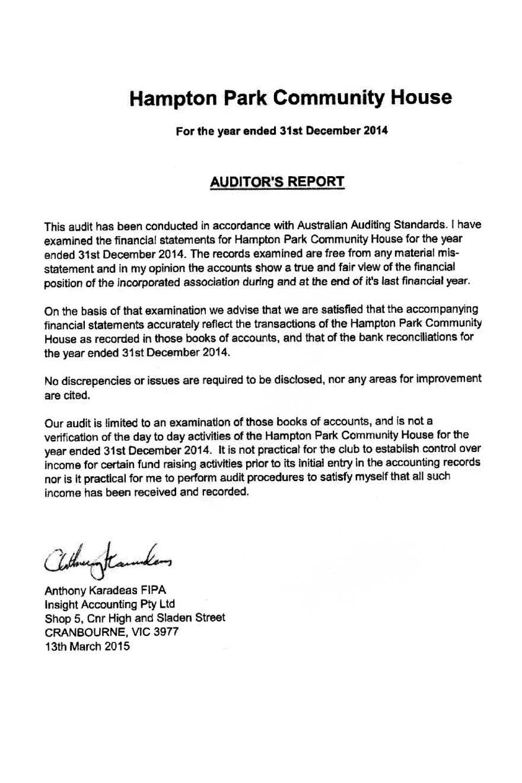

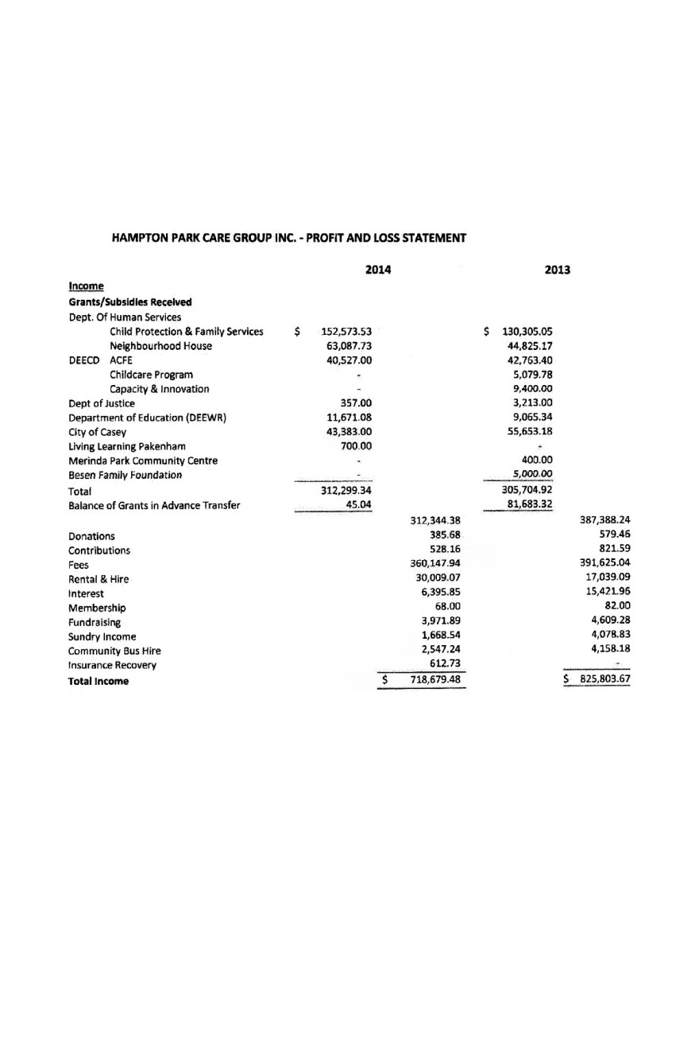

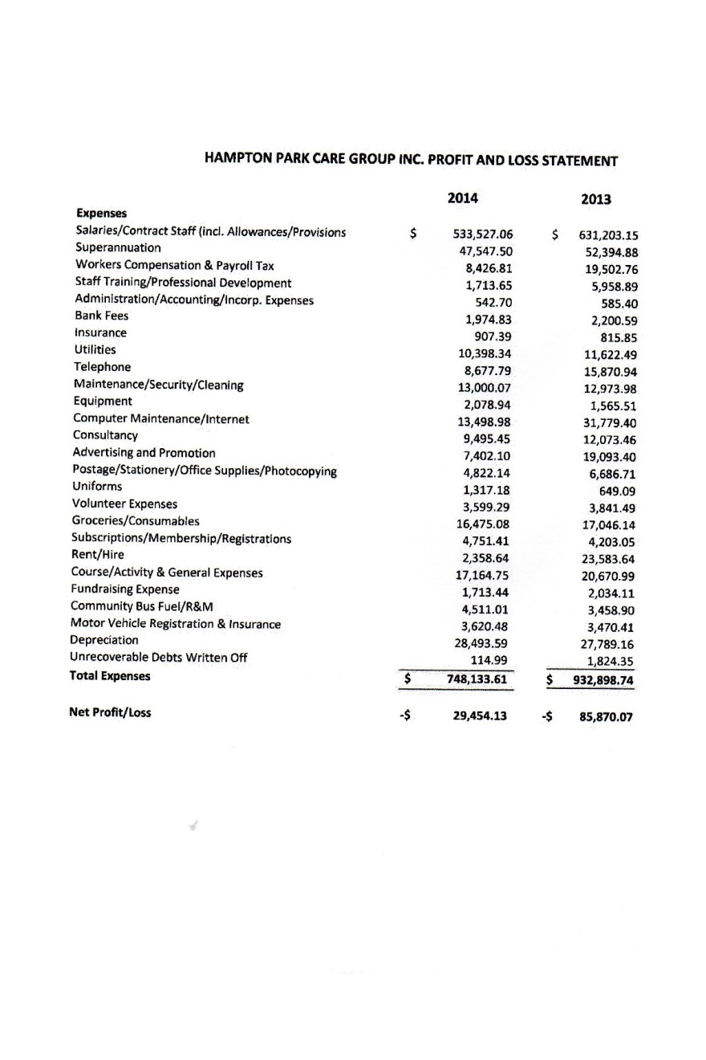

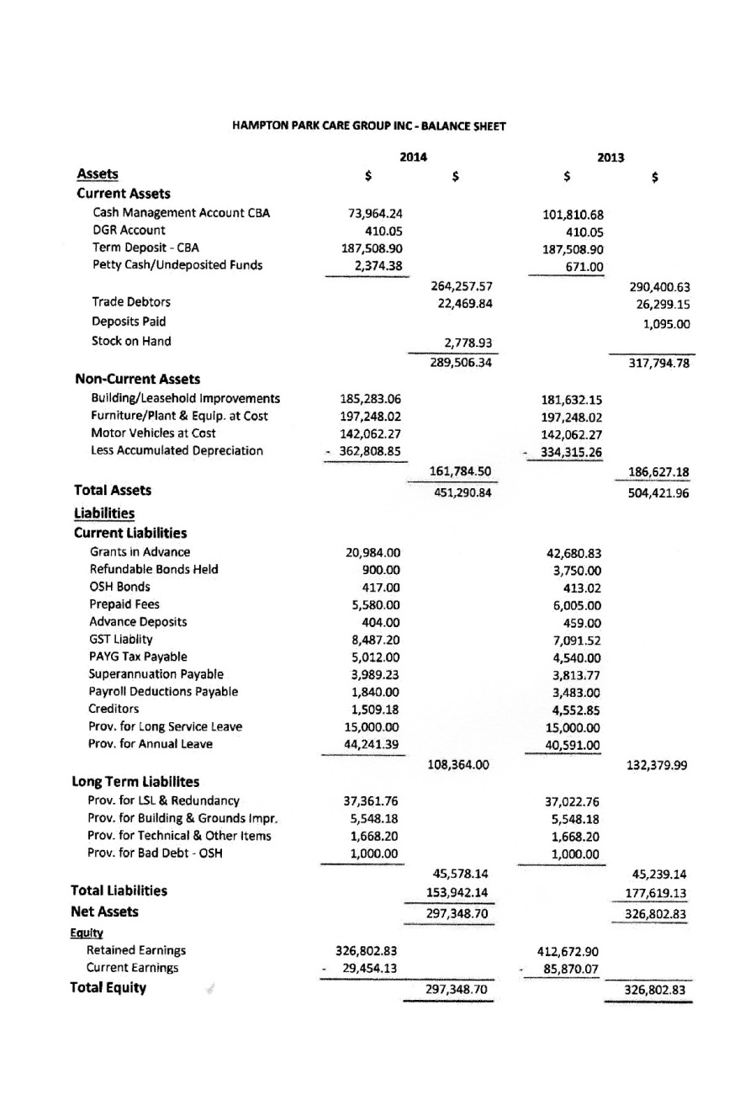

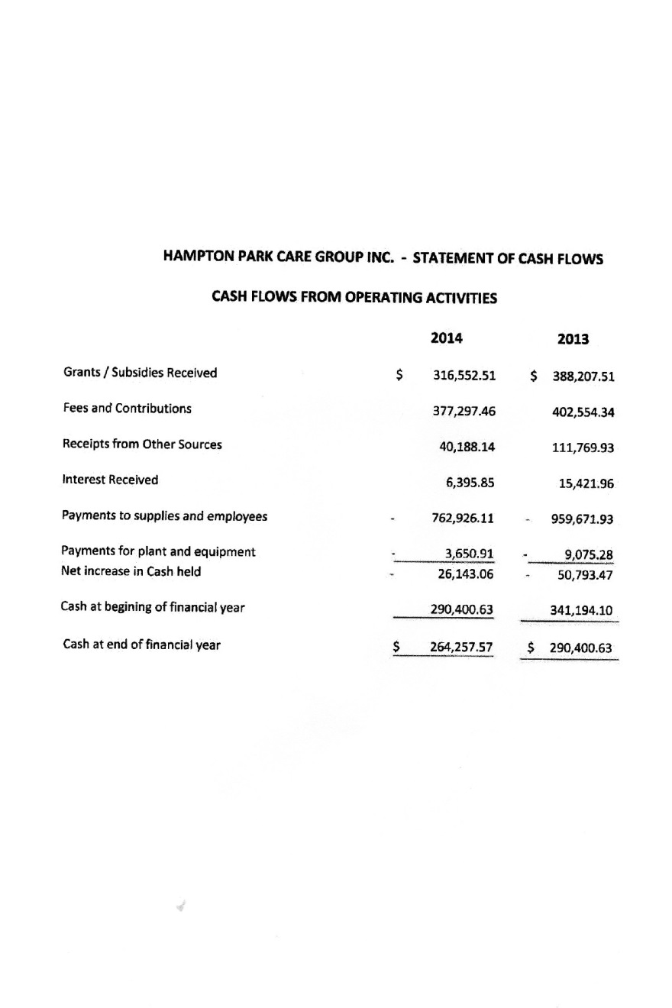

EARLY CHILDHOOD

I am pleased to present the report for 2014.

We had a very busy year; with an increase and a steady number in the Occasional care and Pre-Kinder groups.

Our Occasional Care catered for children from “Culturally and Linguistically Diverse” (CALD) families, Take - a – break parents, Children in need of socialisation and also for a large number of children form the “Adult Migrant English Program” (AMES).

Our pre-kinder area was very successful. We were able to provide 4 morning sessions and two afternoon sessions of Pre-Kinder through the year.

The Victorian Early Years Framework guidelines pinpoint the curriculum which is delivered to the children. Our Educators plan play-based educational programs to support the children’s learning. The programs are planned to meet the individual needs and interests of each child.

Professional Development for Educators has been an ongoing agenda, to be able to implement the changes and support the implementation of the EYLF in our program.

Through the year we were able to provide children with a broad range of learning experiences, such as; the very popular play dough, box construction, bathing babies, home corner, book area, puzzles, Lego, blocks, dressing up, hairdressing, mechanics, and a variety of imaginative play, music and movements. We also provided lots of art experiences such as; painting, pasting, using clay, sand and natural materials and let us not forget the very popular out-door play, where the children enjoy the sand pit, cubby house, climbing, water play, riding bikes, cars and ball games.

During the year we also were happy to provide a special incursion for our children with a visit from “The Country Fire Authority” (CFA). Ray delivered an awareness session for our pre-kinder children (“Fire safe kids program”).

Through the year, we had students from Merinda Park, TBM Training Pty and VCE students doing their placement/work experience hours with us

Big thanks to Rachael Palmer and Lynette who were fantastic Santa’s for us this year.

This year we also had Vicky Michaels joining our pre-kinder educators. She has been a great addition to our team.

We were sad to farewell Peta Stevanovic; we wish her all the best in her future plans.

Many thanks to the childhood educators for providing quality care for the children. Sandra, Peta, Chantal and Vicky are dedicated educators, being always ready to help and support our program.

A big thanks to Wendy, Rachael, Jessica and Patricia, our volunteer staff for always being willing to help us in whatever is needed to be done.

I would like to thank all of the other staff that has supported our area and me as Coordinator this year; Tania as House Manager, Diane for always being there to help, Jan Davies and Janine Gablek as book-keepers, Edith as Family Support Coordinator, the OSHC educators and Sandra on reception.

Thanks to our Board of Governance for 2014 for great support for our area.

I would like to wish the new Board all the very best for the year 2015.

Queenie Tirado,

Early Childhood Coordinator.

OUT OF SCHOOL HOURS

I can’t believe it is a year since my last report, but they say that happens as you get older. It has been another 12 months of lower than average numbers for us with a drop in both before and after school hours care program. The school holiday program numbers seem to remain steady and always feels and sounds very busy.

The children seem to have embraced the Early Years Learning Framework and enjoy making choices and decisions for themselves, and are definitely not afraid to ask for what they want. Unfortunately it is still a no for going to Disneyland & Movie World! This is great for the educators as the children are planning most of the program and we just have to put it all into practice.

Culturally we are very diverse. We have children from all sorts of backgrounds, in fact our families are from 19 different cultures, including Russia, Cyprus, Afghanistan, Fiji, Croatia and Denmark to name but a few. It’s lovely to see all the mixture of children just being Aussie kids.

This last twelve months has seen us go through our first National quality assessment under the early years learning framework. We were all very nervous as to how we were doing, but I am glad to say we got through unscathed. Our program overall is doing very well, even though we had a couple of hiccups in some of our paperwork. They allowed us to rectify this straight away and all is now good.

The children across all of our programs have been very settled and we have had no major behavioural problems, which is always nice. Our incursions and excursions are always popular in the school holidays, and this year has seen us go to Luna Park, the Jump factory and the Drum Theatre. We have also had visits from the fire brigade, mini beasts, kite making and the Guide Dog Association. As well as these days we have had theme days which included a Disney day, all about pets, movies & pyjama days, wear a rainbow, friendship day, jungle theme and lots of arts and crafts.

This year we said goodbye to our educator Jaiyden Watts and one of our school supervisors Linda Hogan.

Our team this last 12 months has been our educational leader Sandra Palmer, Team leader Kelly Yuile, Olga Minotoli, Rachael Palmer, Kathleen Reale and new to us this year Kellie Langley. As we pick up from 5 local schools we also have a team of lovely ladies that collect the children together and supervise them until the bus arrives to pick them up. These include Belinda Haslett, Jane Cameron, Michelle Nicholls, Charmaine Baron and our bus drivers Claudia Alevizos and Lynette Michel.

Thank you to all of these people who help make this program run like a well-oiled machine.

Lastly, thank you to the Board of Governance, the previous manager Lynda Smith, and the present manager Tania Sacco for your continued support. Also to all House staff for always being on call if I need help with anything.

Thank you.

Jan O’Callaghan,

Out of School Hours Coordinator.

PLAYGROUP

2014 has been a wonderful year for Playgroup, we have had a large number of families attending throughout the year, and this year we have seen a rise in the number of grandparents as well as family day carers accessing our playgroup.

Playgroup gives families and carers a regular meeting place outside of their homes that is safe, secure and welcoming, this gives parents and grandparents and carers a chance to meet on a regular basis in a familiar place to:

* To exchange thoughts and ideas on parenting
* To establish new friendship circles
* Maternal Child Health is attending playgroup every term answering parents questions and concerns
* We have had a representative from Tupperware attend several times throughout the year
* For the children to develop social/emotional skills
* To learn about other cultures
* Each term Pete’s Clothing has attended playgroup with parents snapping up lots of bargains
* Through playgroup we hope to encourage families to attend regularly and to start thinking seriously about attending 3 year old kinder which is a good stepping stone towards 4 year old kinder and their child’s future
* This year we have been encouraging families to recycle by using the worm farm as much as possible
* We have incorporated a variety of celebrations into our program throughout the year including Harmony Day, Easter, national simultaneous story time, dental health week, Mother’s day and Father’s day, just to name a few
* Lots of interest in the vegetable garden in particular the strawberries and tomatoes
* For families to develop a love of music and movement
* We continue to sell chocolate frogs as an ongoing fundraiser

The Afghan playgroup has had a great year. Our numbers have grown quiet a lot over the last 12 months. Parents are really starting to understand the importance of enrolling their children in 3 and 4 year old kinder as well as attending school on a regular basis. We have had regular visits throughout the year from the Maternal Child Health Nurse. The parents have initiated having a clothes swap in both children and adult clothing. We have had a visit from our local library. The SPPI Officer Jodie Soutter has given us lots of support and advice throughout the year.

The City of Casey once again has provided a great end of year party at Myuna Farm which is available to all playgroup members and their families throughout the City of Casey. All who attended had a wonderful time.

Once again we decided to have 2 separate parties for end of year break up as this seems to suit everyone. Santa arrived bearing gifts and lolly bags for all, much to the delight of the children. I would like to express my thanks to our 2 wonderful Santa’s- Lynette and Rachael who did a wonderful job on the day, children and parents were happy with the gifts that they received as well as the compulsory lolly bags. Once again Santa came along to the Afghan playgroup; I’m not sure who was the most excited about this, the children or the parents.

I would like to say thank you to all of the volunteers who have willingly given up their time so regularly, in particular Sandra Marks, Jessica Riddiford, Rachael Palmer and Laura Palmer without the help of these lovely people playgroup would struggle to run, I would also like to say thank you to all staff and committee members for their help and support throughout the year. All at playgroup are looking forward to a successful and fun filled year next year.

Sandra Palmer,

Playgroup Co-ordinator.

FAMILY SUPPORT

I am pleased to present this year’s Family Support report.

It has been a very exhilarating year in the Family Support Office. Family Support received the ISO:9001 Certificate of Approval on March 2014 to be working and meeting the requirements of DHS Standards.

Family Support has been unsuccessful in recruited new Case workers during the year. We decided that we were only going to recruit the right people for these positions and we are yet to find a good fit. We will however continue to try in 2015.

Family Support has had a very busy year, seeing many clients. This includes families, couples and lots of children. Family Support receives referrals from Child First / DHS as they provide our funding. Family Support has case managed 91 clients over the year. Many of the issues covered and supported were Parenting support and Education, Child Behaviour and Bullying, Isolation and Depression, Family violence, Drug and Alcohol, Grief and Loss, Relationship counselling and migrant concerns.

*Feeling is Thinking Group*

The Children’s Feeling is Thinking group (FisT) is performing well and improving every term. Kristy, (Case manager from Windermere) and I are responsible in keeping the group running successively. We have had many children go through the Feeling is Thinking group, 45 in the past year with many different outcomes and accomplishments for the children whom attended the group. This group will be ongoing during the course of the next year and hopefully countless years to follow. To see the changes in the children’s life is inexpressible and I am delighted to be part of their lives for a short period of time, to see the fun times and strengths they achieve while attending the group.

I would like to take this opportunity to thank the Board of Governance for their support during the year and to both managers of the Community House during 2014, Lynda Smith and Tania Sacco. Michael Scargill for all his volunteer hours during the year with IT and admin work, also to Diane Spencer and Sandra Hoy for their support.

A big thank you to DHS, for their funding and commitment of this Area: to Moritz Muckenberger for his continued support.

Edith Schaaf,

Family Support Coordinator.

PROGRAM COORDINATOR

I would like to present the Program Coordinators report for 2014.

What a full on year. I started the year as Program Co-ordinator and ended doing that and more. I could not have managed it all without the help and support of the Administration team, Diane Spencer, Sandra Hoy and Jen Schutze. In order to keep the programming running, we were able to utilize Jen on a 3 month contract at the end of year to make sure everything got done. Jen has been an asset to the existing team and with luck hopefully will continue to be so in 2015.

We were fortunate to be awarded 5000 Student contact hours again in 2014 and at the year of the year we had delivered 5001 SCH.

As per normal we delivered our usual compliment of English and Computer classes to an area that is still greatly in need of these types of courses and ones that are affordable. Its thanks to ACFE (Adult Community and Further Education) that we are able to provide this sort of affordable training.

Due to my transition mid-year, while we were able to continue to provide our normal compliment of courses we were not able to expand as much as we would have liked. We did however manage to land in the black for the year and in the current economic environment I would consider that a win.

We did however manage to keep the Youth Pre-Employment program afloat and provided them additional networking opportunities with the Dandenong Valley Special Development School in the form of dance lessons to prepare these special needs students for their end of year formal. This was a roaring success and one we hope to repeat in 2015.

We are looking into the future to try and provide as many opportunities to our community as we can. However due to less staff we will be trying to bring the classes to us more often, while still maintaining what we do best that being ESL and Computer classes.

I would also like to extend a big thank-you to the Dandenong Community House and their Manager Robyn Coslovich for her continuing help, especially in the area of her tutor bank. This proved invaluable in keeping our classes going when tutors left and also doubled in keeping great tutors employed within our sector.

We say a semi farewell to Monica who has run our ESL classes for many years. As of 2015 she will only be running the night classes. Many thanks Monica and don’t be a stranger.

Tania Sacco, Program Coordinator &

Jen Schutze, Assistant Program Coordinator.

Words from the MANAGER

My goodness where do I start?

Never in my wildest dreams did I think that in 2014 I would be taking over the Managers position at the Hampton Park Community House, but in July 2014 that’s exactly what happened.

And what it year it has been. I have spent the last 6 months getting my head around intricacies of the position and learning all about the parts of the House that I had previously not had a lot to do with. As well as conducting the role of Manager I am now also responsible as the Quality Manager for our ISO: 9001 accreditation and I have assumed the mantle of HR Manager as well.

2014 proved to be a year of transition and consolidation. There was a lot of work to be done throughout the House and I could never have got through it without all the help and support from every single member of staff and Board. You all made my transition from co-worker to Management seamless and for that I am truly grateful.

We had a tough year financially and many belts needed to be tightened which I feel we did in true Hampton Park spirit. It’s hard to take full credit for the year as I was only in the hot seat for half of it but the way we managed to turn around a considerable operating loss into a more positive one was encouraging and I’m sure that this will now continue into 2015.

The other department heads have covered everything so there is no need for me to repeat what they have already covered. It seemed that I blinked and it was the end of the year. The Hampton Park Community House is a never ending whirlwind of people, classes and programs. The thing that I am the most proud of is our ability to always keep a human face to all that goes on here. While we always strive to promote the House and keep moving our processes in a business direction, we never lose our stance on providing a safe and hospitable place for anyone that needs it. People comment on the fact that when you walk in our doors the atmosphere is always one of help, consideration and friendliness, that’s not something can be taught and I couldn’t be more proud of all that contribute to this wonderful place. I first walked through the front door 14 years ago needing help with my then babies and I’m so blessed to still be here and hope to still be for many years to come.

I would like to give a special thanks to the Board for giving me this opportunity and to those of you (you know who you are) for all your help.

Tania Sacco,

Manager.

APPENDIX

*Board of Governance 2014*

**Chairman**

John O’Callaghan

**Vice Chairman**

Peter Hanson

**Treasurer**

Julie Sullivan

**Secretary**

Christie Stoneham

**General**

Michael Scargill

Ann Green

*Community House Staff 2014*

**House Manager**

Lynda Smith

Tania Sacco

**Administration**

Diane Spencer

Sandra Hoy

Jan Davies

Janine Gablek

**Out of school Hours**

Jan O’Callaghan

Kelly Yuile

Olga Minotoli

Rachel Palmer

Kellie Langley

Kathleen Reale

Michelle Nichols

Claudia Alevizos

Jane Cameron

Belinda Haslett

**Child Care**

Queenie Tirado

Sandra Palmer

Vicki Michaels

Patricia Tirado

Wendy Slavovic

Chantal Jose

Peta Stevanovic

**Family Support**

Edith Schaaf

**Programs & Volunteers**

Jen Schutze

Monica Singh

John Dowswell

Sandra Marks

Elaine Youens

Jessica Riddiford

Laura Palmer

**Friends of the House**

Sue Stephens

Elaine Smith

Heather Shepherd

Mary Murphy

Melinda Perry

Alison Kramer

David Maxwell

Warren Calder

Lynda Smith

Vanassa Gerdes

*Acknowledgments*

For the continued assistance and contributions, Hampton Park Care Group Inc. would like to thank:

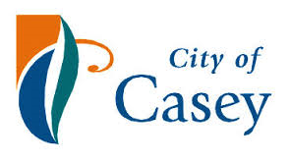















Description: Description: (DET) Insignia Blue Left Aligned

The Community House Network and all of our wonderful volunteers

Thank you.